**JDBC Using Maven and Mysql**

**Step1:**

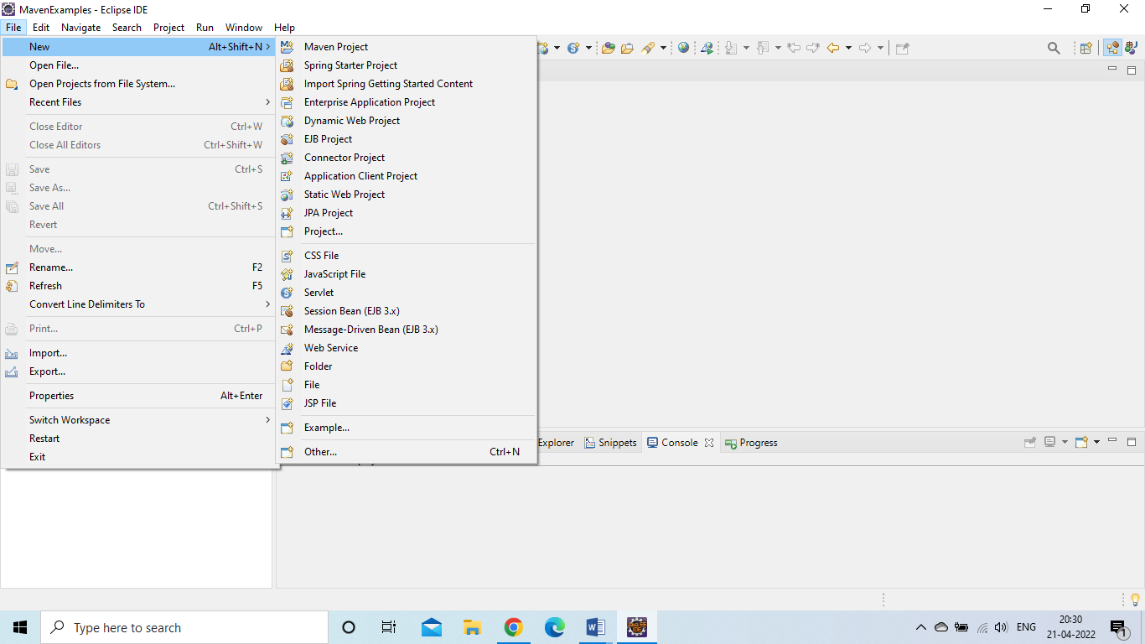

**Step 2:**

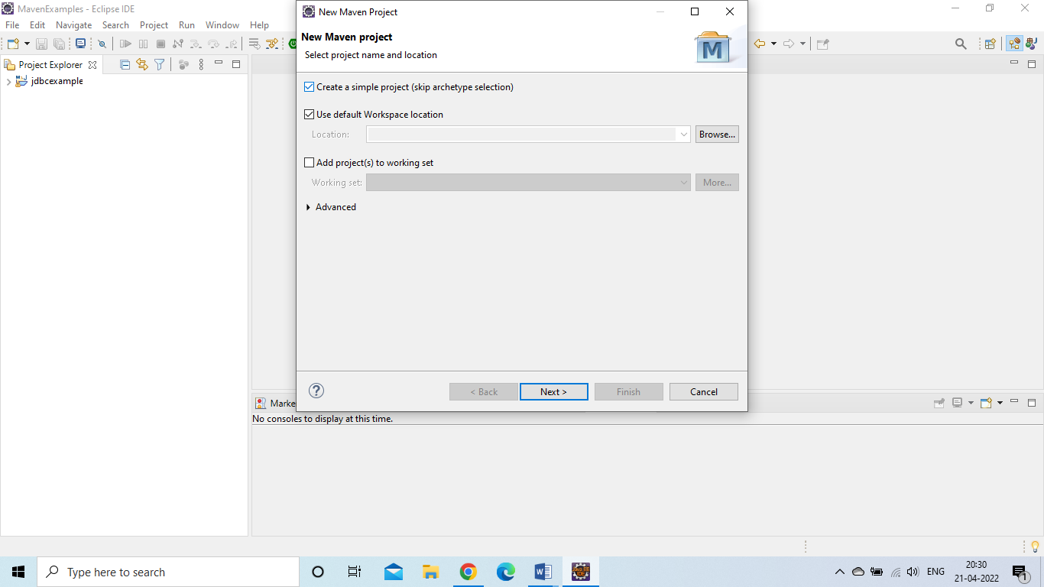

**Step 3:**

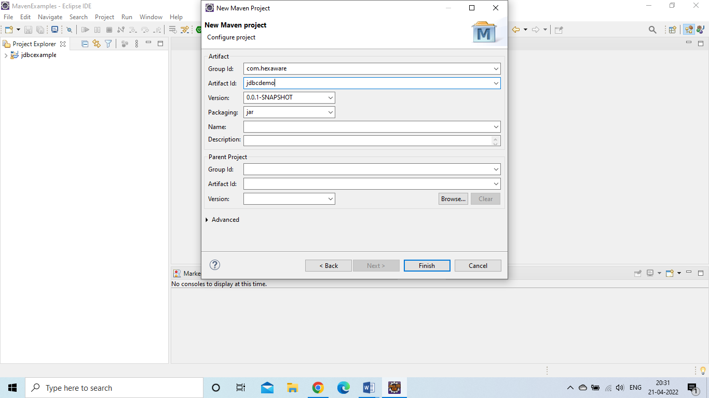

**Step 4: Open pom.xml**

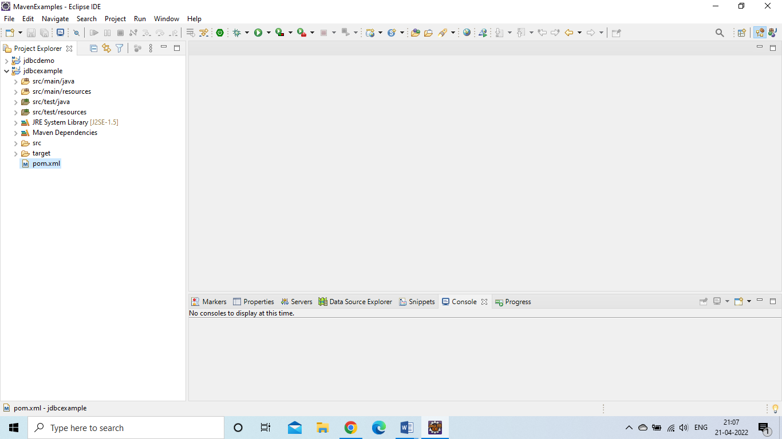

**Step 5:**

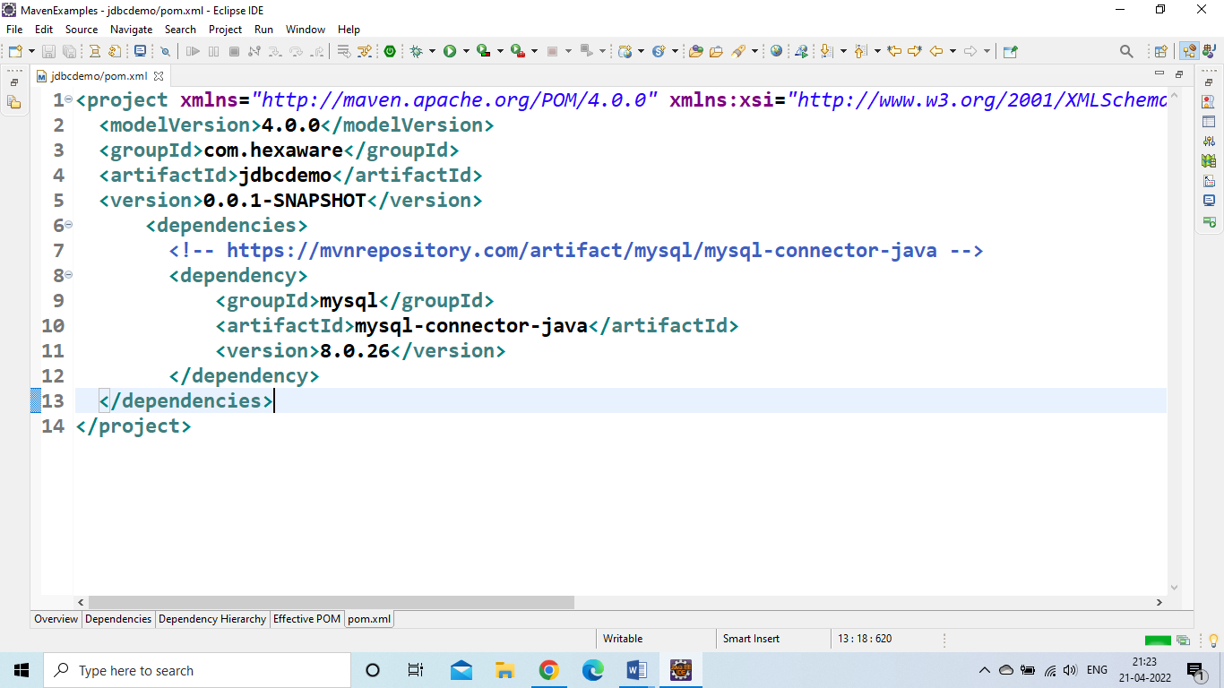

**Add below code to pom.xml file**

<dependencies>

<!-- https://mvnrepository.com/artifact/mysql/mysql-connector-java -->

<dependency>

<groupId>mysql</groupId>

<artifactId>mysql-connector-java</artifactId>

<version>8.0.26</version>

</dependency>

</dependencies>

**Step 6:**

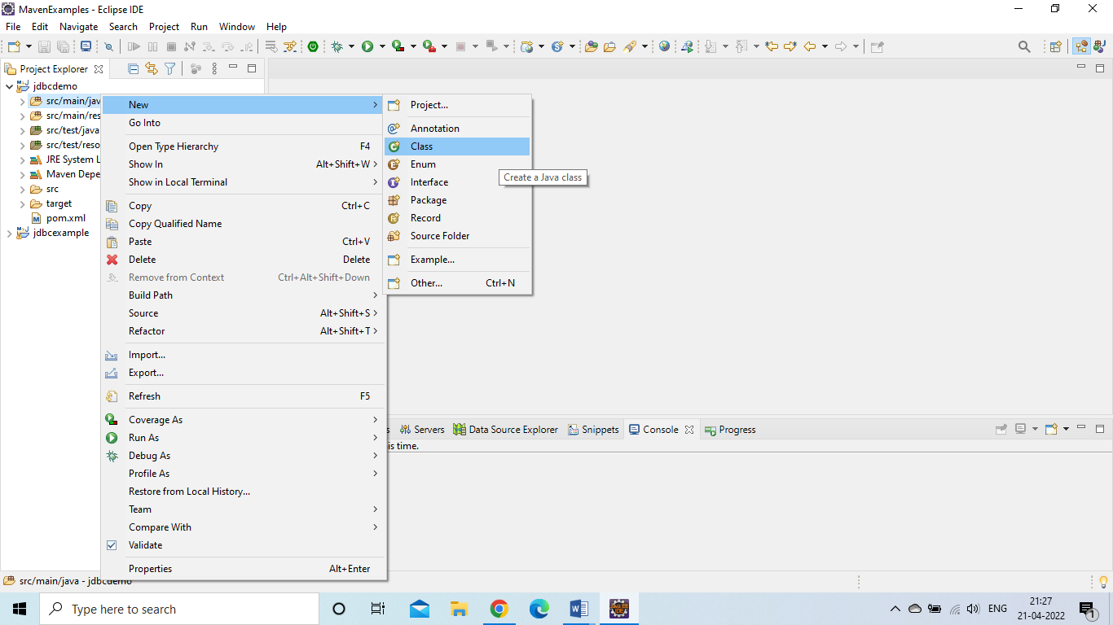

**Step 7:**

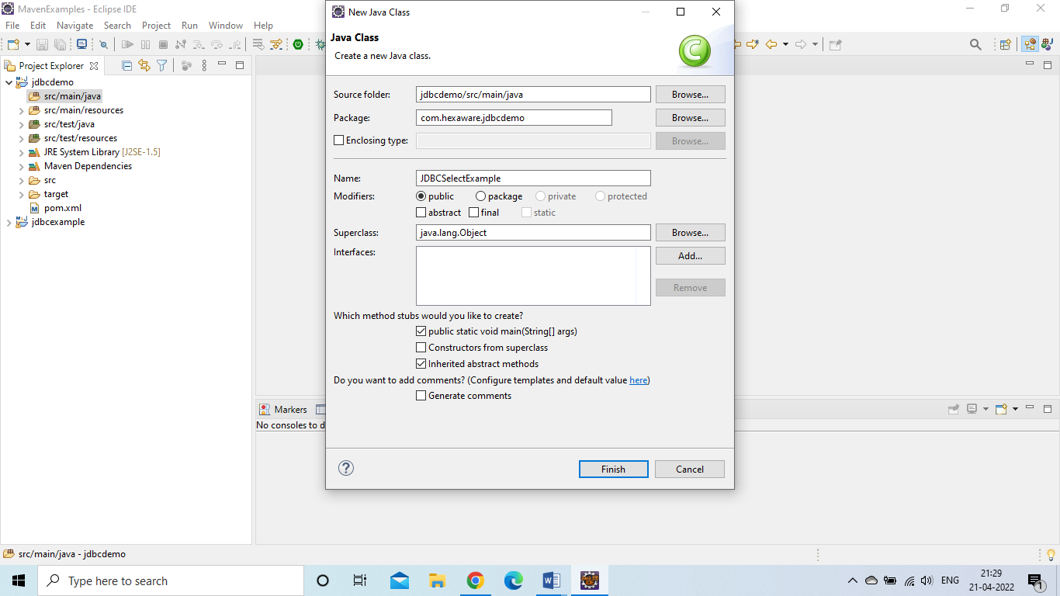

**Step 8: Add the following code to above created class**

Connection conn = **null**;

**try** {

//step 1:

Class.*forName*("com.mysql.cj.jdbc.Driver");

//step 2:

conn = DriverManager.*getConnection*("jdbc:mysql://localhost:3306/hexawarepget2022",

"root",

"root");

//step 3:

Statement stmt = conn.createStatement();

//step 4:

ResultSet rs = stmt.executeQuery("select * from customers");

//extract the result from the above result set

**while**(rs.next()) {

System.***out***.println(rs.getString(2));

}

} **catch** (Exception e) {

// **TODO** Auto-generated catch block

e.printStackTrace();

}**finally** {

**try** {

conn.close();

} **catch** (SQLException e) {

// **TODO** Auto-generated catch block

e.printStackTrace();

}

}

**Step 9: Run the Program**

